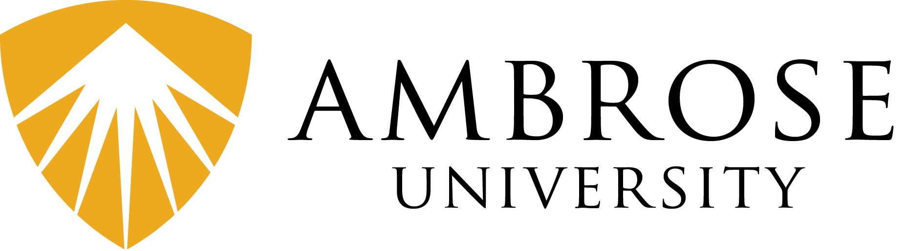

Approval for Licensing Information Sheet 2023

Approval for Licensing with the Christian and Missionary Alliance in Canada allows candidates to seek and apply to work full-time in ministry. On behalf of the National Ministry Centre, Ambrose University organizes the opportunity for Ambrose University students to go through the Approval for Licensing process and be interviewed by districts from across Canada.

[Note: licenses have a two-year shelf life. Students need to coordinate when they choose to go through the Approval for Licensing process with their graduation plan.]

Approval for Licensing Documents

All Approval for Licensing documents and resources are available on the Approval for Licensing page on the Field Education website at fielded.ambrose.edu.

Documents  *Please send all completed documents/forms to fielded@ambrose.edu | Reference Forms & Police Check  - Professor Reference Form  - Reference Form for 5 references  - Police check (with vulnerable sector search)  Document Package  - Application Form for Licensed Ministry  - Biographical Inventory  - Doctrinal Questionnaire  - Church Interview Form  - Call to Excellence  - Statement of Faith  - Policy on Process for Mediation & Arbitration  - Guiding Principles - Cessationism
Resources | - Licensing Interview Package – Applicant Interview Study Guide  - Manual of the Christian and Missionary Alliance in Canada  - Lines of Authority and Accountability in the Christian and Missionary Alliance  - C&MA Distinctives Video

Important Dates

Approval for Licensing Information Meeting | September 28, 2022
Deadline for indicating if you are going to complete Approval for Licensing this year.  [Note: send email message to fielded@ambrose.edu] | October 17, 2022
Due Date for References, Police Check and Licensing Fee:  - Professor Reference Form  - 5 Reference Forms  - Police Check (with vulnerable sector search)  - Payment of $60 C&MA licensing fee to Finance Office | November 14, 2022
C&MA Distinctives Workshop and Study Guide Review | December 6, 2022
Sign up for licensing interview & career opportunity meetings (i.e. February 1-3, 2022) | December 9, 2022
Due Date for Document Package:  - Application Form for Licensed Ministry  - Biographical Inventory  - Doctrinal Questionnaire  - Church Interview Form  - Call to Excellence  - Statement of Faith  - Policy for Process on Mediation & Arbitration  - Guiding Principles - Cessationism | January 9, 2023
Licensing Interview Preparation Workshop | Jan 18, 2023
Approval for Licensing Interviews & Career Opportunity Meetings | Jan 31 &Feb 1, 2023

Key Contact

- Ric Strangway (Coordinator of Field Education) | Email: Ric.Strangway@ambrose.edu | Phone: (403) 410-2000 ext. 4902 | Office: L2047
- Kelly Martin (Field ed Assistant) Email: Kelly.Martin@ambrose.edu |Phone:403(410-2000 ext., 6923 |Office L2044

